Report
Of
GenAI-Powered Data Analytics: A Practical Job Simulation with Tata

Submitted
To
School of Computer Science and Engineering
IILM University, Greater Noida, U.P.

In partial fulfilment of the requirement of degree of
B.Tech CSE



By
Roll Number of Student:25scs1003002773
Name of Student: ANSHU KUMAR GUPTA
Batch: 2026-27

CHAPTER 1: CANDIDATE’S DECLARATION

I, Anshu Kumar Gupta do hereby declare that the internship report titled “GenAI-Powered Data Analytics: A Practical Job Simulation with Tata” has been completed by me to fulfil the requirement for the award of the degree of Bachelor of Technology in CSE. All the references have been quoted and I have not taken as such any material from any other source. I affirm to you that this report is my own and has not been submitted to any other institute for any degree/diploma requirement and further I shall be solely responsible for any kind of copyright violation in this regard.

Signature Anshu Kumar Gupta
Student Name: Anshu Kumar Gupta
Roll No.25SCS1003002773

CHAPTER 2: ACKNOWLEDGEMENT

I am using this opportunity to express my gratitude to everyone who supported me throughout the Internship Program. I am thankful for their aspiring guidance, invaluably constructive criticism and friendly advice during this work. I am sincerely grateful to them for sharing their truthful and illuminating views on a number of issues related to this work.
I express my gratitude to my parents for their blessings.

Signature Anshu Kumar Gupta
Student Name: Anshu Kumar Gupta
Roll No:25SCS1003002773

CHAPTER 3: Internship Completion Certificate

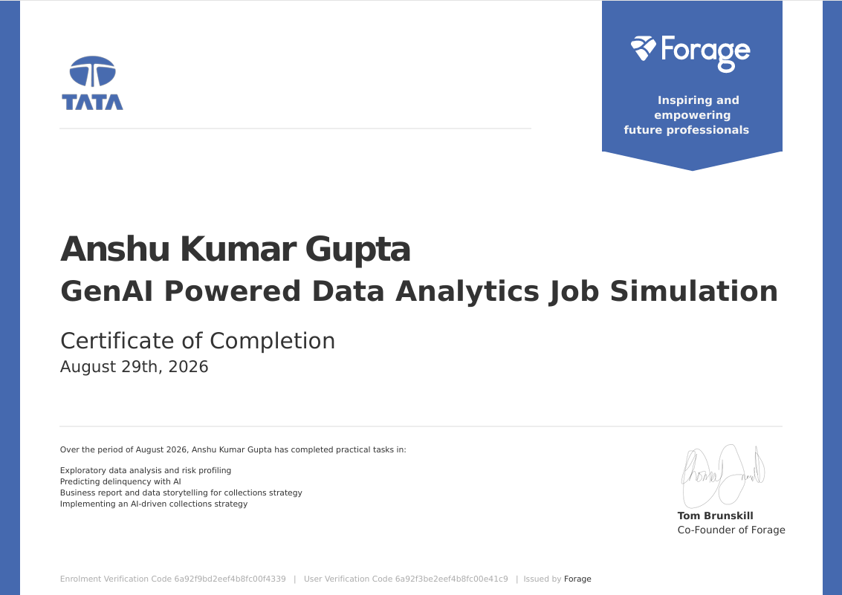

CHAPTER 4: Project Description
4.1 Introduction
Data analytics means collecting and studying data to find useful information from it. It helps a company understand its data and make better decisions. Nowadays, Artificial Intelligence (AI) is also being used with data analytics to make the work faster and easier.
I completed the GenAI-Powered Data Analytics Job Simulation provided by Forage with Tata. This simulation gave me an idea of how data analytics and AI are used in real business work.
During the simulation, I worked on different tasks such as data analysis, risk profiling, predicting customer delinquency using AI, preparing business reports, and creating an AI-based collections strategy.
This report explains the work I completed during the simulation, the tools and methods used, and the knowledge I gained from this experience. It also helped me understand how data and AI can be useful for solving business problems.

4.2 Organization Profile – Tata
Tata Group is one of the well-known business groups in India. It was founded by Jamsetji Tata in 1868. The Tata Group has many companies working in different areas such as technology, automobiles, steel, consumer products, finance, and other services.
Tata has also focused on new technologies and digital solutions to improve its business activities. Data analytics and Artificial Intelligence (AI) are useful in understanding business data and making better decisions.
As part of the Forage job simulation, I got an opportunity to work on a project related to GenAI-powered data analytics with Tata. The simulation was based on a business problem related to customer delinquency and collections. It helped me understand how data can be used to identify risks and support better collection strategies.
Through this simulation, I learned about the practical use of data analysis, AI, risk profiling, and business reporting in a real-world business situation.

4.3 Problem Statement
In many businesses, a large amount of customer data is generated every day. It can be difficult to study this data manually and identify which customers may have a higher risk of delayed payments.
The main problem of this project was to analyze customer data and identify the factors related to delinquency. The aim was to use data analysis and AI to understand customer risk and help the business take better decisions.
The project also focused on developing a suitable collections strategy. By using the available data, customers could be grouped according to their risk level, which could help in deciding how they should be approached.
Through this simulation, I learned how a business problem can be converted into a data analysis problem and how the results can be used to support practical business decisions.

4.4 Project Objectives
The main objective of this project was to understand how data analytics and Generative AI can be used to solve a business problem. The main objectives of the project are:
- To understand and analyze customer data
- To identify customers who may have a higher risk of delayed payments.
- To study different factors related to customer delinquency.
- To use AI for predicting possible delinquency.
- To prepare a simple business report based on the analysis.
- To understand how data can help in making better collection decisions.
- To develop an effective AI-driven collections strategy.
- To gain practical knowledge of data analytics and AI through a real-world business simulation.

4.5 Scope of the Project
The scope of this project is mainly related to the use of data analytics and AI in customer payment and collections activities. The project focuses on studying customer data and finding useful information that can help in business decision-making.
The main areas covered in this project are:
- Analyzing customer data to understand important patterns.
- Identifying customers based on their risk level.
- Understanding the factors that may lead to delayed payments.
- Using AI to help predict customer delinquency.
- Presenting the analysis in the form of a simple business report.
- Using the results to suggest a suitable collections strategy.
- Understanding the practical use of GenAI in data analytics.

4.6 Technologies and Tools Used

1. Generative AI
Generative AI was used to understand the data, generate useful insights, and support the analysis process. It helped in working with the customer data and understanding possible risk factors.
2. Data Analytics
Data analytics was used to study the available customer information and identify useful patterns. It helped in understanding customer risk and payment-related problems.
3. Data Visualization
Data visualization was used to present important information in an easy-to-understand way. Charts and other visual methods can make data comparison and analysis easier.
4. Business Reporting
Business reporting was used to present the findings of the analysis in a simple and organized format. It helped in explaining the results and suggesting suitable actions.
5. AI-Based Prediction
AI-based methods were used to understand and predict the possibility of customer delinquency. This helped in identifying customers who may need more attention.

4.7 System Architecture
The system architecture shows the basic flow of how customer data is analyzed and used to make business decisions. In this project, data analysis and AI are used together to understand customer risk and improve the collections process.
The basic flow of the system is:

Customer Data: Customer-related information is taken as the input for analysis.

Data Collection & Preparation: The available data is checked and prepared for further analysis.

Exploratory Data Analysis: The data is studied to find important patterns and relationships.

Risk Profiling: Customers are grouped according to their risk level.

AI-Based Prediction: AI is used to identify customers who may have a higher chance of delinquency.

Business Insights: The results are studied to understand the main findings.

Collections Strategy: The findings are used to plan a suitable approach for customer collections.

4.8 Methodology

The methodology used in this project explains the steps followed to analyze the customer data and develop a suitable collections strategy. The work was completed step by step during the Tata GenAI-Powered Data Analytics Job Simulation.
Steps Followed
1. Understanding the Problem
First, the business problem was understood. The main focus was to identify customer risk and understand the possibility of delayed payments.
2. Data Understanding
The available customer data was studied to understand the different information and factors present in the dataset.
3. Data Analysis
The data was analyzed to find useful patterns and relationships. This helped in understanding customer behaviour and risk levels.
4. Risk Profiling
Customers were studied and grouped according to their level of risk. This helped in identifying customers who may require more attention.
5. AI-Based Prediction
AI was used to support the prediction of possible customer delinquency. The results helped in understanding which customers could be at higher risk.
6. Business Reporting
The important findings from the analysis were organized into a business report. Data storytelling was used to explain the results in a simple manner.
7. Collections Strategy
Finally, the findings were used to develop an AI-driven collections strategy. The strategy focused on using customer risk information to support better decisions.

4.9 Expected Outcomes

The main expected outcome of this project is to understand how data analytics and AI can be used to solve business problems. The job simulation provides practical knowledge of analyzing customer data and using the results for better decision-making.
The expected outcomes are:
Better understanding of customer data and its analysis.
Identification of important factors related to customer delinquency.
Understanding of customer risk through risk profiling.
Use of AI for predicting possible delinquency.
Better understanding of business reporting and data storytelling.
Development of a suitable AI-driven collections strategy.
Improvement in data analysis and problem-solving skills.
Understanding of how AI can support business decisions.

4.10 Certificates of completion and other communication mail proof must be attached


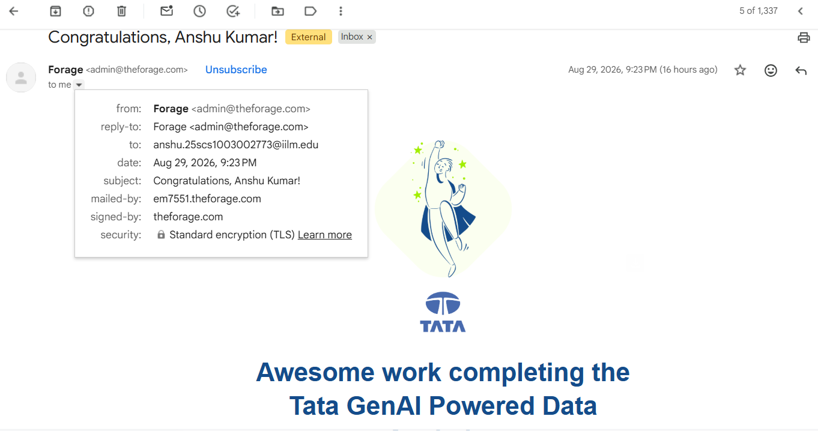
CHAPTER 5: BIBLIOGRAPHY
- Tata Insights and Quants. (2026). GenAI Powered Data Analytics Job Simulation. Forage.
- McKinney, W. (2022). Python for Data Analysis: Data Wrangling with Pandas, NumPy, and Jupyter (3rd ed.). O’Reilly Media.
- Géron, A. (2022). Hands-On Machine Learning with Scikit-Learn, Keras, and TensorFlow (3rd ed.). O’Reilly Media.
- James, G., Witten, D., Hastie, T., & Tibshirani, R. (2021). An Introduction to Statistical Learning: With Applications in R (2nd ed.). Springer.
- Han, J., Kamber, M., & Pei, J. (2011). Data Mining: Concepts and Techniques (3rd ed.). Morgan Kaufmann.
- Provost, F., & Fawcett, T. (2013). Data Science for Business: What You Need to Know about Data Mining and Data-Analytic Thinking. O’Reilly Media.
- Forage. (2026). GenAI Powered Data Analytics: Exploratory Data Analysis, Predictive Analytics and AI-driven Collections Strategy. Forage Job Simulation. Forage Job Simulations⁠�

